Lab - Use Wireshark to Compare Telnet and SSH Traffic

**Additional Note:** Yellow highlighted text indicates all of my answers.

*(672021159)*

# Objectives

* Use Wireshark to capture web browser traffic.
* Use Wireshark to capture Telnet traffic.
* Use Wireshark to capture SSH traffic.

# Background / Scenario

Wireshark is a network protocol analyzer that lets you see what’s happening on your network at a microscopic level. You can capture packets and store them for offline analysis. Wireshark includes many tools for deep inspection of hundreds of network protocols. In this lab, you will use Wireshark to capture and inspect web traffic, Telnet traffic, and SSH traffic.

# Required Resources

PC with the **CSE-LABVM** installed in VirtualBox.

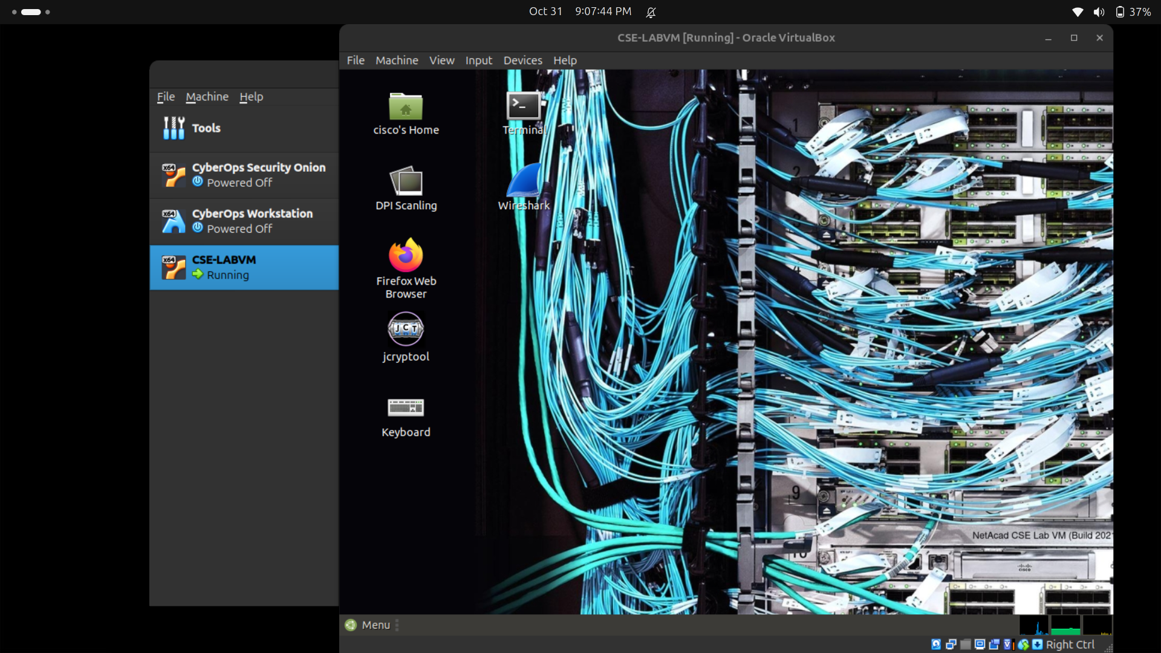

# Instructions

## Open a terminal window in the CSE-LABVM.

* + 1. Launch the **CSE-LABVM**.
    2. Double-click the **Terminal** icon to open a terminal.
    3. 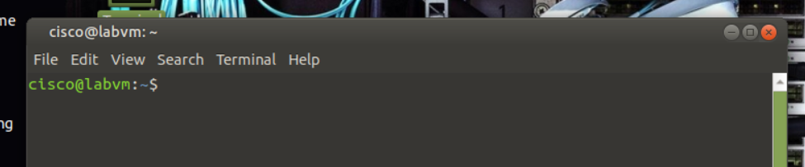

## Explore the Wireshark protocol analyzer.

* + 1. To capture traffic on your VM, you need to run Wireshark in promiscuous mode, which requires running with escalated privileges using **sudo**. Enter the **sudo wireshark** command, and then enter **password** for the password. The Wireshark graphical user interface (GUI) will open up.

cisco@labvm:~$ **sudo wireshark**

[sudo] password for cisco: **password**

QStandardPaths: XDG_RUNTIME_DIR not set, defaulting to '/tmp/runtime-root'

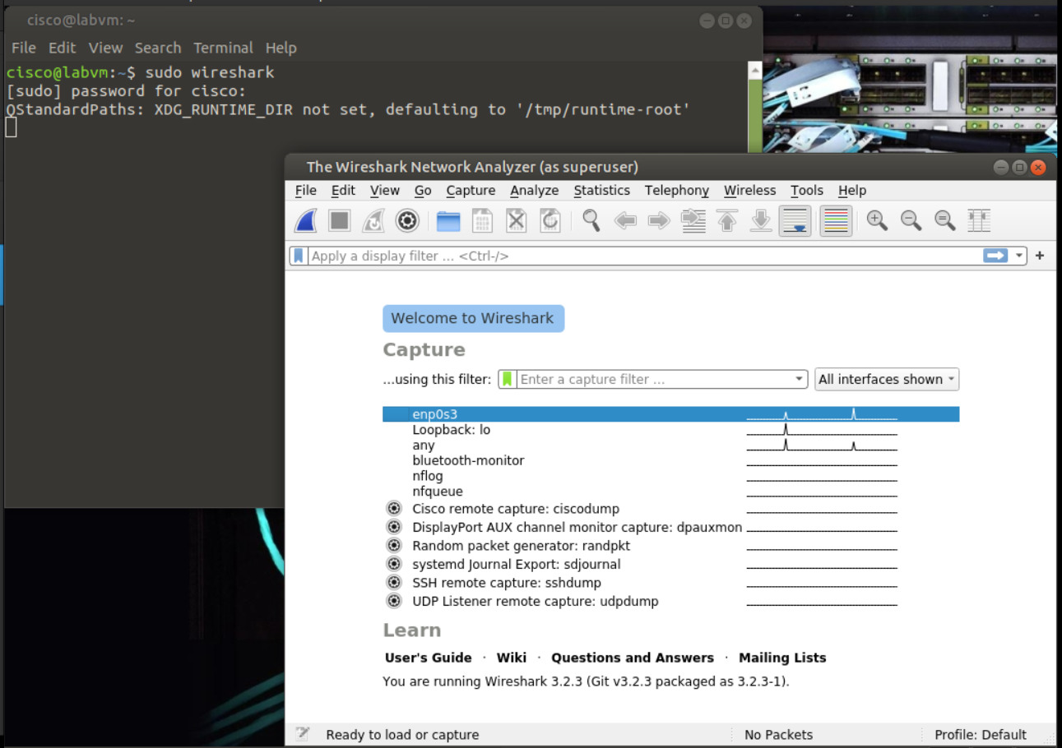

* + 1. Under the listing of interfaces, select **any**, and then click **Capture** > **Start** from the menus. Alternatively, you can click the shark fin icon. Wireshark will begin capturing packets.
    2. 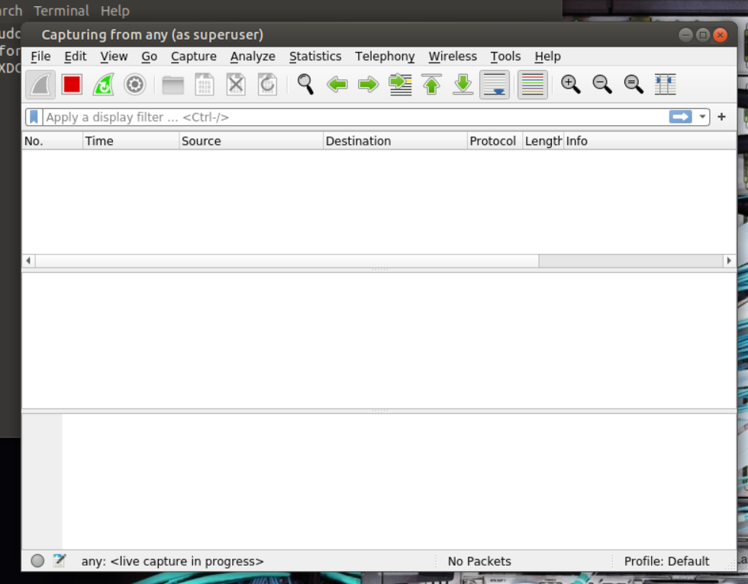
    3. If you already have Firefox open, you may see traffic captured in the Wireshark interface. If Firefox is not open, go ahead and open it now. In Wireshark, you should now see captured TCP traffic in the top third of the window.
    4. 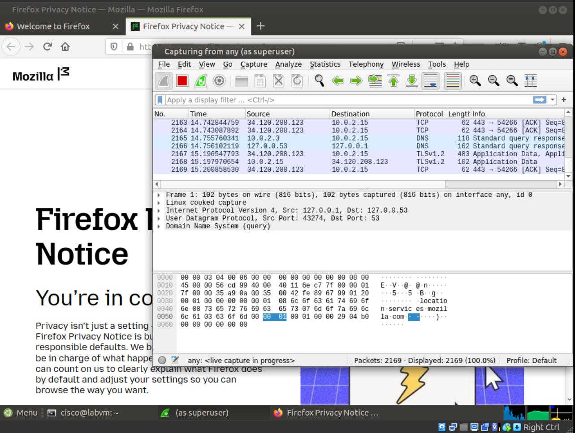
    5. In Firefox, enter www.cisco.com to visit the Cisco website. After the website loads, you can close Firefox.
    6. 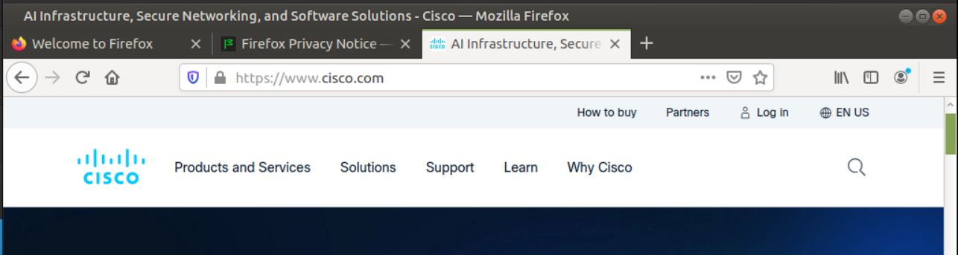
    7. Return to Wireshark and click **Capture** > **Stop** from the menus. Alternatively, you can click the red square button next to the shark fin.
    8. 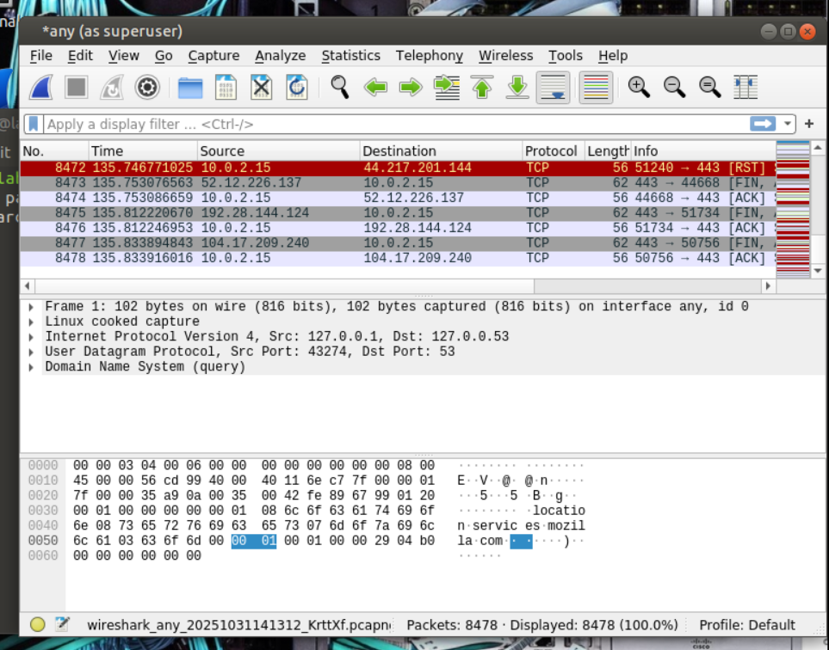
    9. In Wireshark, you will see the filter field and three key panes or work areas:
    10. 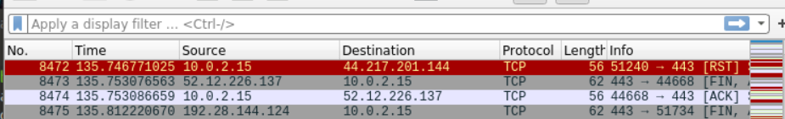
* The **Apply a display filter** field is directly below the toolbar.
* The **Packet List** pane includes the following columns for each captured packet:
* **No** - the number of the packet (in numerical order).
* **Time** - the timestamp of the packet
* **Source** - the source IP address of the packet
* **Destination** - the destination IP address of the packet
* **Protocol** - the protocol of the packet
* **Length** - the number of bytes captured for this packet
* **Info** - additional information about the packet’s content
* The **Packet Details** pane shows the protocols and protocol fields of the selected packet. Notice that the fields can be expanded or collapsed by clicking the arrow next to the field.
* The **Packet Bytes** pane shows the byte details of the selected packet. As you select parts of the packet in the Packet Details pane, the corresponding bytes will be highlighted in the Packet Bytes pane. The left side shows the hexadecimal representation of the bytes, and the right side shows the ASCII representation.

## Capture and analyze unencrypted Telnet traffic.

* + 1. Start a new capture. In the **Unsaved packets…** dialog box, click **Continue without Saving**. This will clear out the packets from your last capture and start a new capture.
    2. 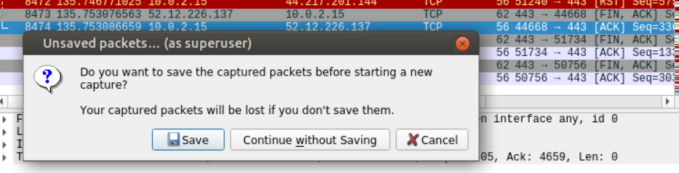
    3. Double-click the **Terminal** icon to open a new terminal window.
    4. 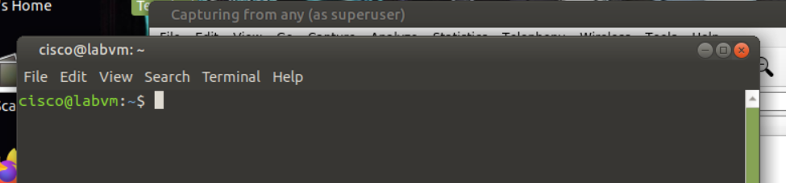
    5. You can simulate a remote login to your VM by entering the **telnet localhost** command, and then logging in as **cisco** with **password** as the password.

cisco@labvm:~$ **telnet localhost**

Trying ::1...

Trying 127.0.0.1...

Connected to localhost.

Escape character is '^]'.

Ubuntu 20.04.2 LTS

labvm login: **cisco**

Password: **password**

Welcome to Ubuntu 20.04.2 LTS (GNU/Linux 5.4.0-67-generic x86_64)

* Documentation: https://help.ubuntu.com

* Management: https://landscape.canonical.com

* Support: https://ubuntu.com/advantage

0 updates can be installed immediately.

0 of these updates are security updates.

Last login: Thu Mar 18 21:47:23 UTC 2021 on tty2

cisco@labvm:~$

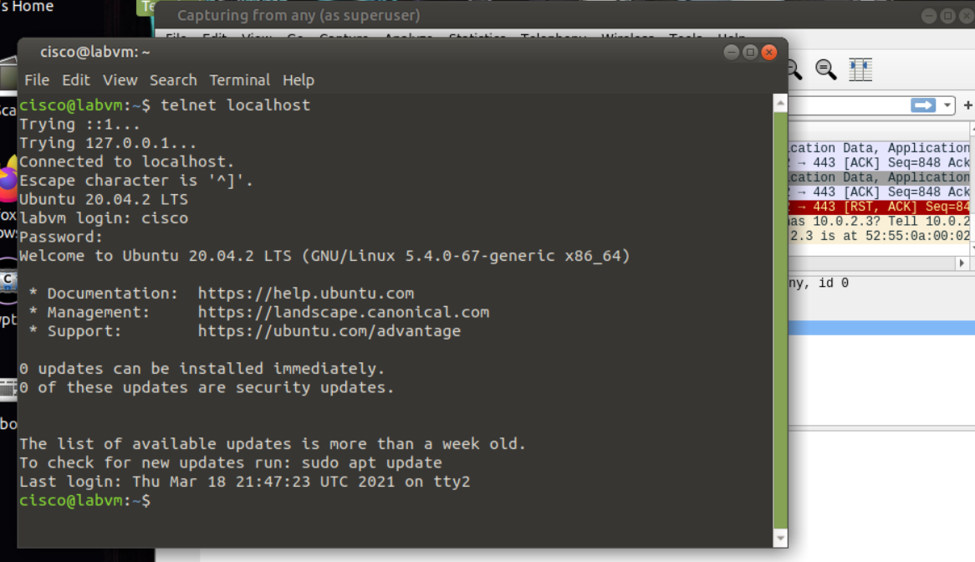

* + 1. Enter the **exit** command to end the Telnet session:

cisco@labvm:~$ **exit**

logout

Connection closed by foreign host.

cisco@labvm:~$

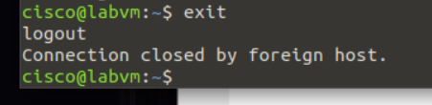

* + 1. Return to Wireshark and stop the capture.
    2. 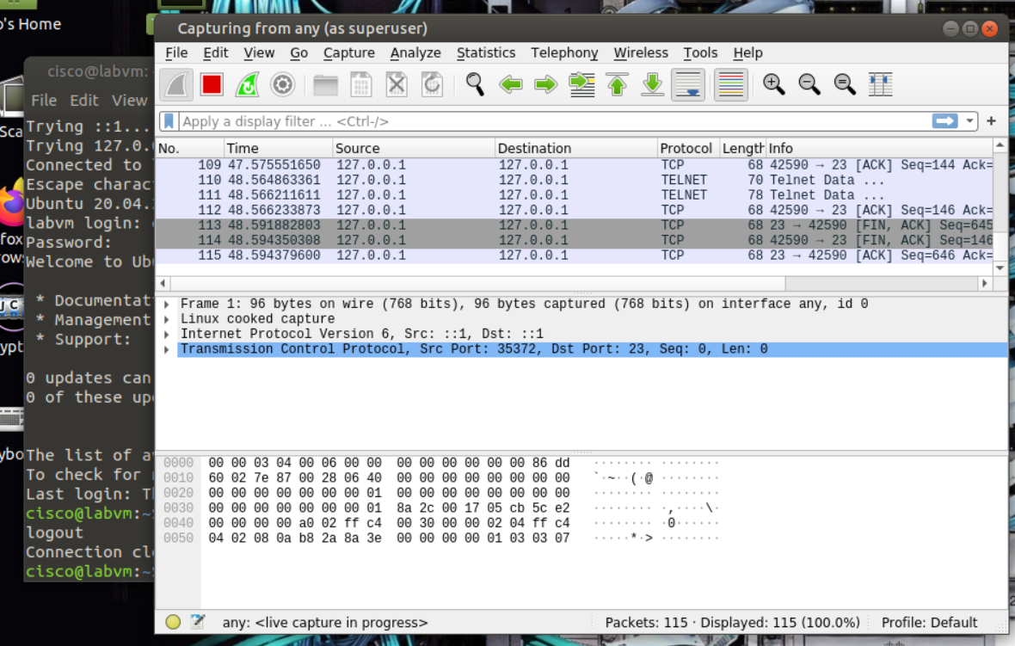
    3. In the **Apply a display filter** field, type **telnet** and press **Enter** to filter for only Telnet packets.
    4. 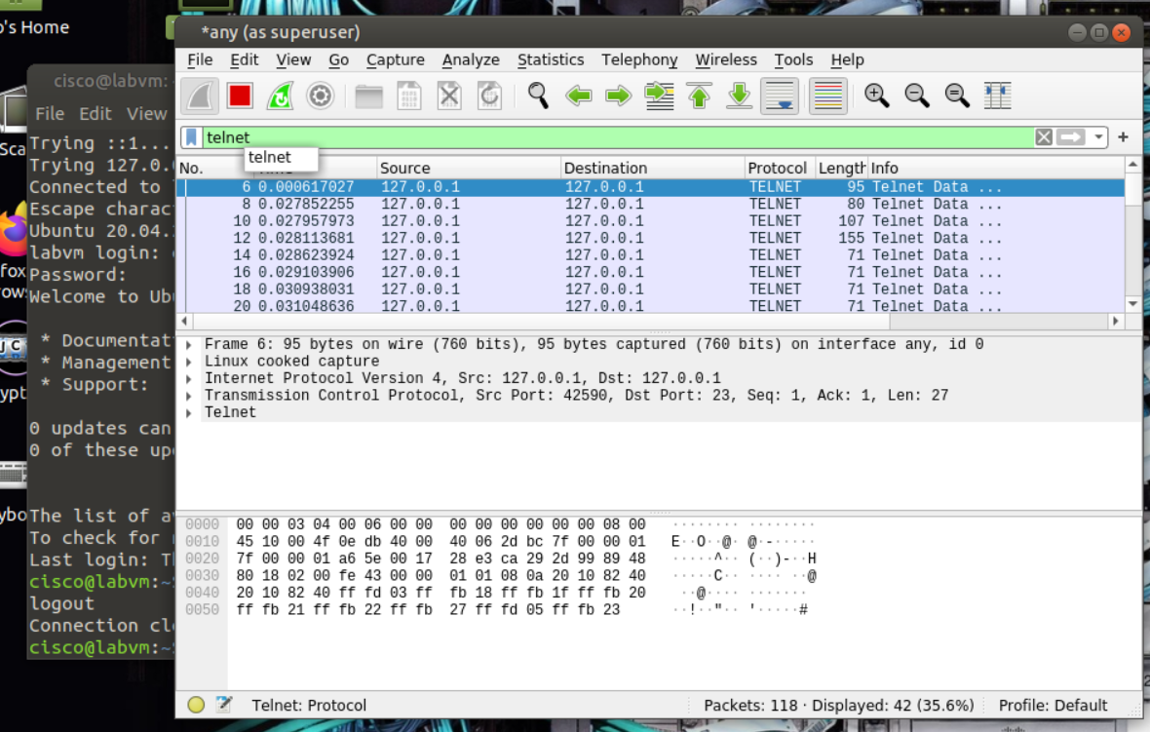
    5. On the toolbar, click the magnifying glass icon to **Find a packet**. Additional search features are now shown below the **Apply a display filter** field.
    6. 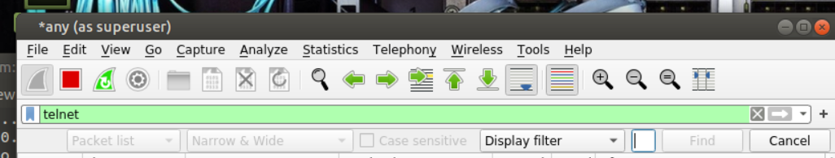
    7. Click the arrows next to **Display filter** and change it to **String**. Then click the arrows next to Packet list and change it to **Packet details**.
    8. 
    9. To find the packet requesting login information, type **labvm login:** in the field next to **String**, and then press **Enter** or click **Find**. Wireshark will highlight the packet that contains the "labvm login:" text string.
    10. 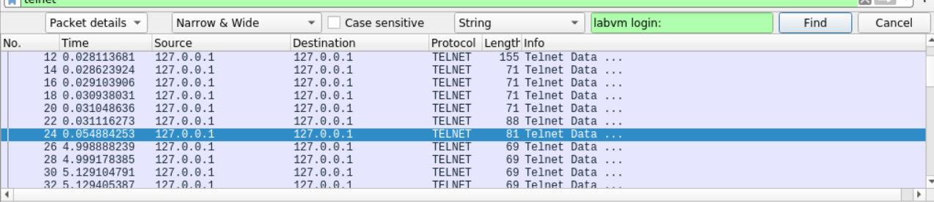
    11. In the **Packet Details** pane, click the arrow next to **Telnet** to expand its content. You should see that **labvm login:** is the data for this packet. The data for the packet is also shown in **Packet Bytes** pane. You can tell that the text was sent unencrypted because you can read it.
    12. 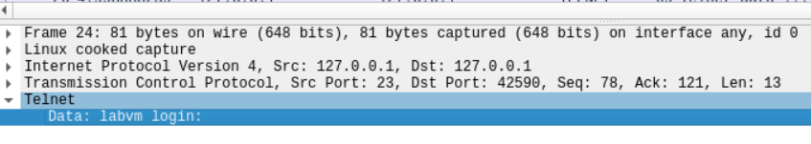
    13. In the **Packet List** pane, click the highlighted packet with **labvm login** as the data to select it.
    14. 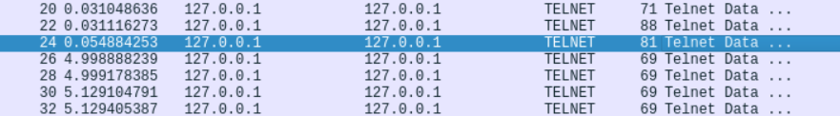
    15. To find the username and password, use your down arrow on the keyboard to select the next packet. In the **Packet Details** pane, you should see the value for **Data** under **Telnet** is the first letter you typed in the field for "labvm login:" prompt, which was **c** for **cisco**. If you click the down arrow again, you will see the next packet's data is also **c**. This is because the packet is listed twice: one time for source sending to destination and again for destination receiving the packet. Because the source and destination are the same interface (loopback 127.0.0.1), the packet is listed twice by Wireshark.
    16. 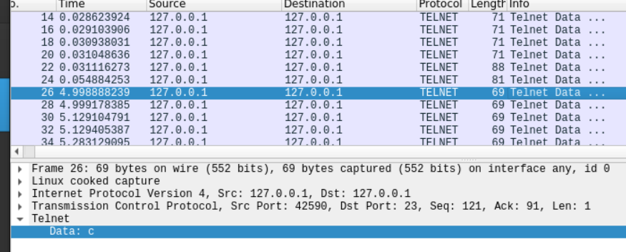
    17. Continue to press the down arrow key until you reach the last packet with a data value of **o** for the username **cisco**.
    18. 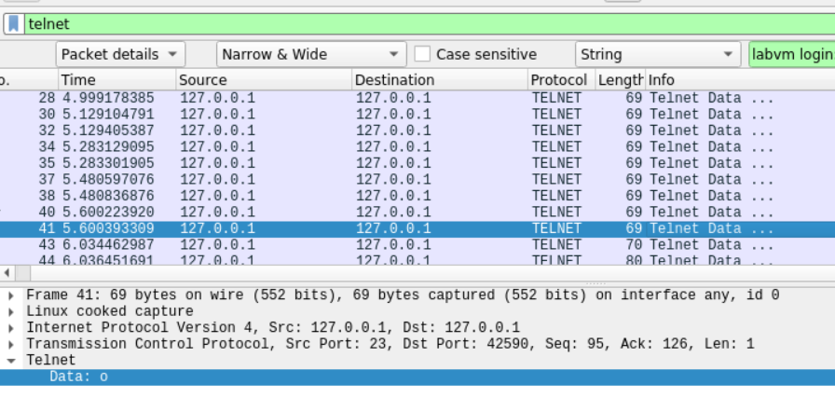
    19. Continue to click the down arrow until you will see **Password:** in the **Data** field. Continue pressing the down arrow to read the data of the next eight packets which reveal, one letter at a time, that **password** is the password for user **cisco**.
    20. 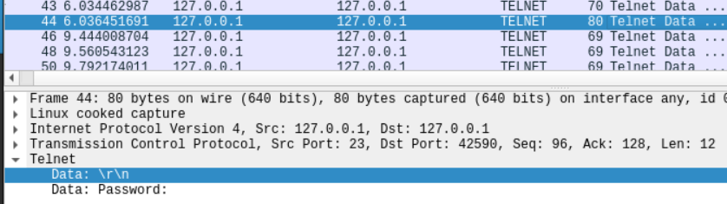
    21. 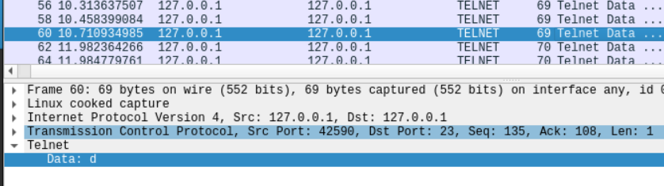
    22. If you continue to press the down arrow through the rest of the captured packets, you will see all the text sent and received during the Telnet session, including your **exit** command and the **logout** message.
    23. 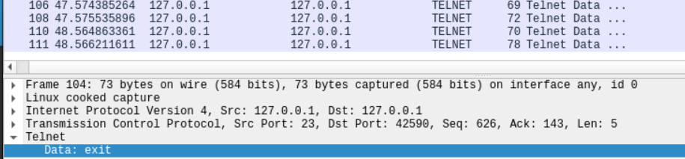
    24. 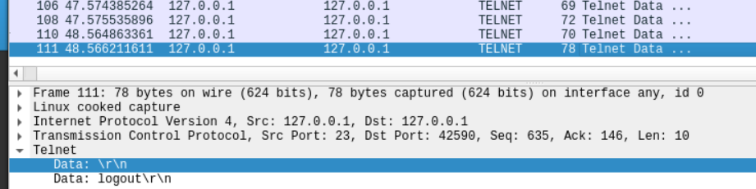

## Capture and analyze encrypted SSH traffic.

* + 1. Start a new capture. In the **Unsaved packets…** dialog box, click **Continue without Saving**. This will clear out the packets from your last capture and start a new capture.
    2. 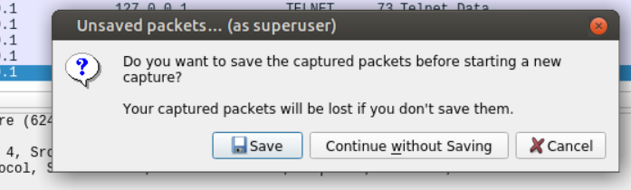
    3. Return to your open terminal window or start a new terminal session.
    4. 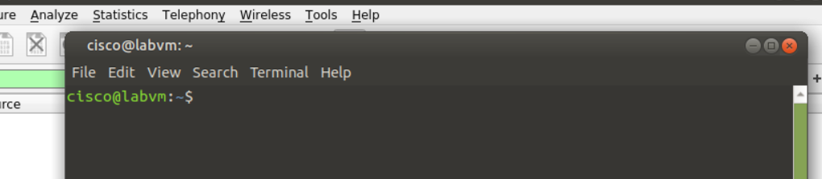
    5. To simulate an SSH login, enter the command **ssh localhost**. If this is your first time to use the command, the system warns you about the authenticity of localhost and asks you if you want to continue. Enter **yes**, and then **password** as the password to log in.

cisco@labvm:~$ **ssh localhost**

The authenticity of host 'localhost (::1)' can't be established.

ECDSA key fingerprint is SHA256:lEvtfM55v9O8L88uvZ4Em/UL4ARo8jWGE1hV8mVnDhQ.

Are you sure you want to continue connecting (yes/no/[fingerprint])? **yes**

Warning: Permanently added 'localhost' (ECDSA) to the list of known hosts.

cisco@localhost's password: **password**

Welcome to Ubuntu 20.04.2 LTS (GNU/Linux 5.4.0-67-generic x86_64)

* Documentation: https://help.ubuntu.com

* Management: https://landscape.canonical.com

* Support: https://ubuntu.com/advantage

0 updates can be installed immediately.

0 of these updates are security updates.

Last login: Thu Mar 25 14:01:58 2021 from localhost

cisco@labvm:~$

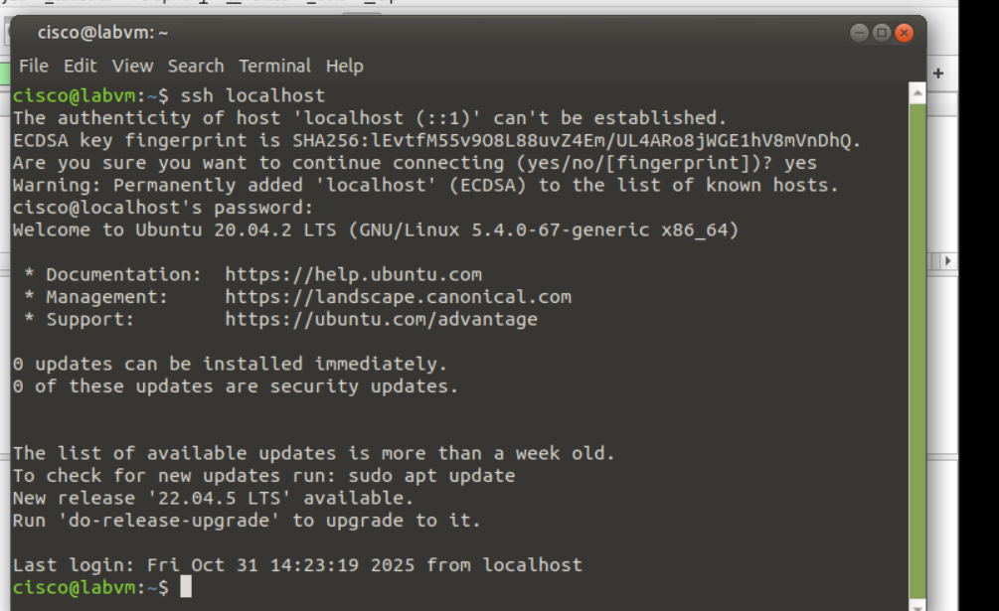

* + 1. Enter the **exit** command to end the SSH session.
    2. 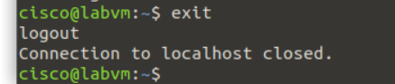
    3. Return to Wireshark and stop the capture. If you left **telnet** as the search term in the **Apply a display filter** field, no packets will be listed. Change the search term from **telnet** to **ssh**. All the packets from your SSH session should now be shown in the **Packet List** pane.
    4. 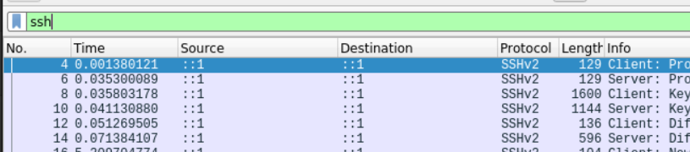
    5. In the **Packet Details** pane, expand the **SSH Protocol** fields to view the content. In the **Packet List** pane, click the first packet, and then use the down arrow to view a variety of the SSH packets. Notice that the **Data** for the **SSH Protocol** field shows that all the data is encrypted.
    6. 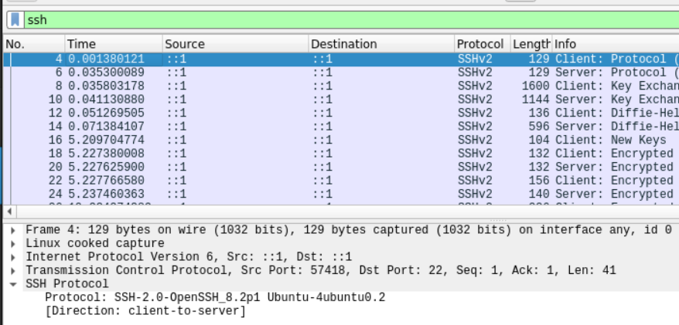
    7. 